Create Repo

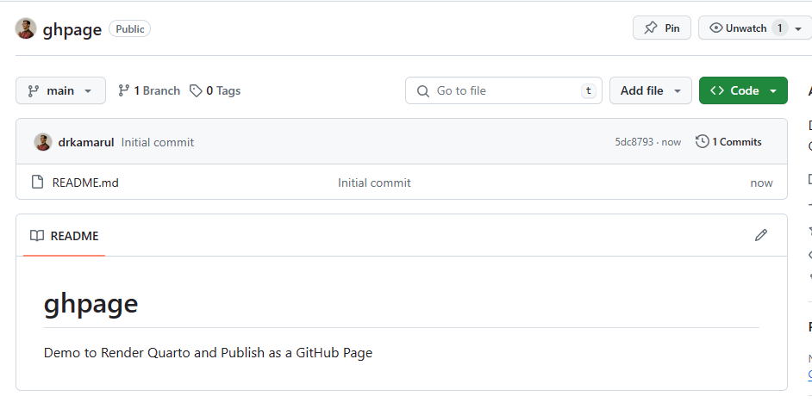

Copy Repo to Clone on Local Machine

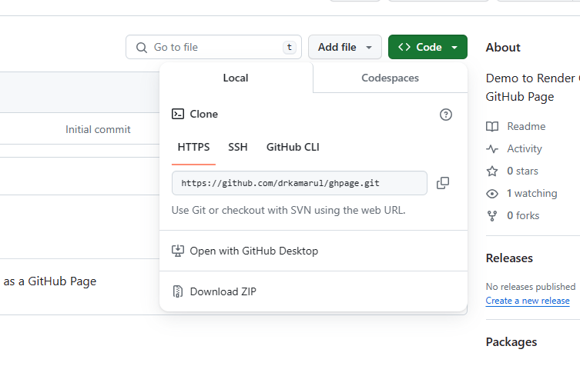

Clone and create local repo

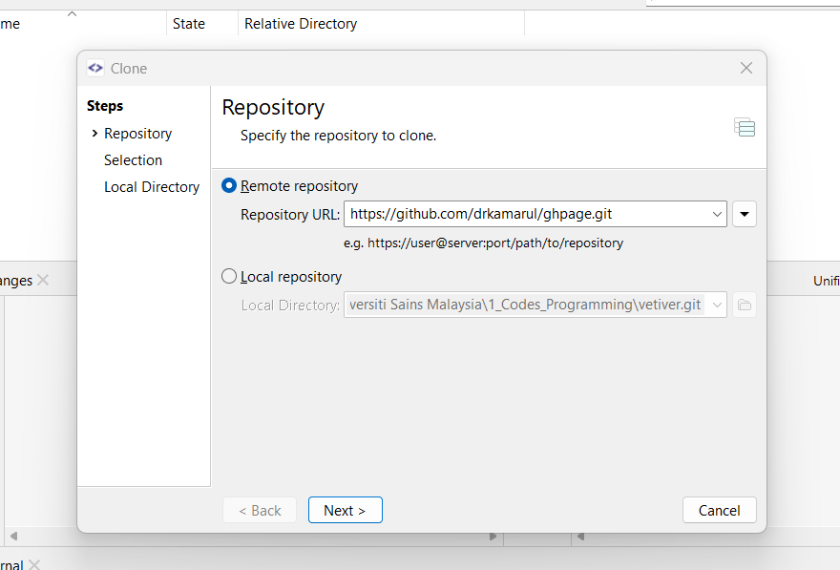

Local Repo

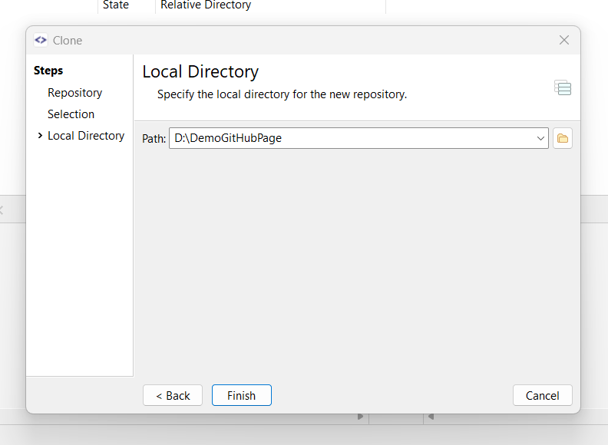

The content of local repo

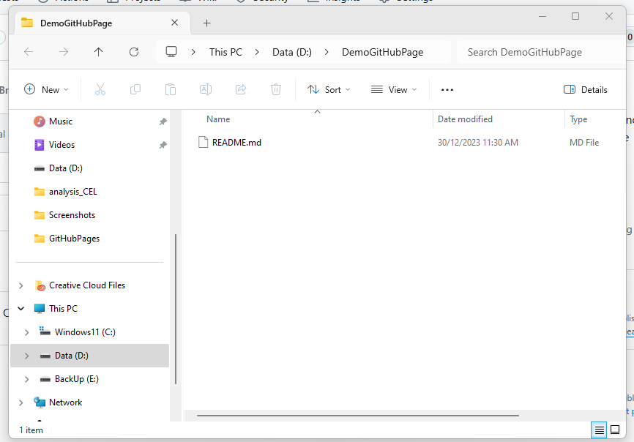

Create a New Project

New Directory (will not work on existing directory)

Quarto Website

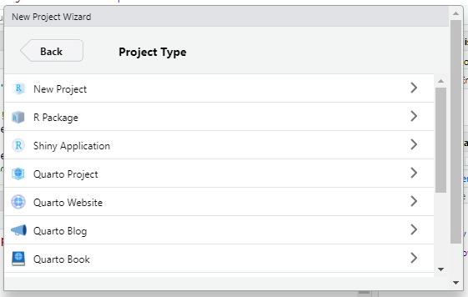

Generate a directory name

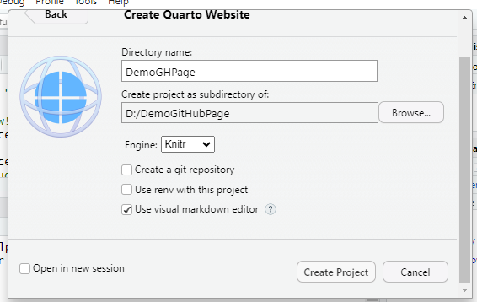

Create contents

New File -> New Quarto Document -> HTML

In this example, I create a new link “visualization.qmd”

Then write your codes as usual

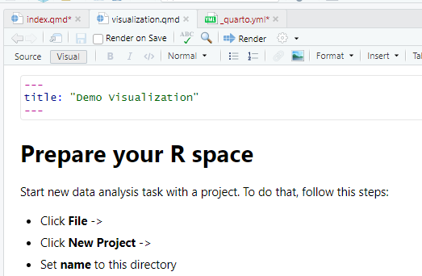

Create an entry “output-dir: docs”

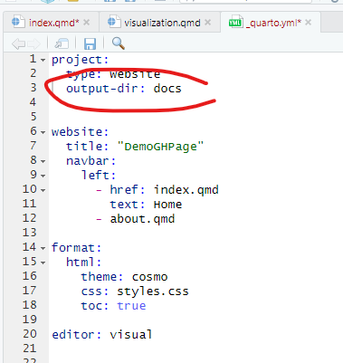

Then Render the index.qmd

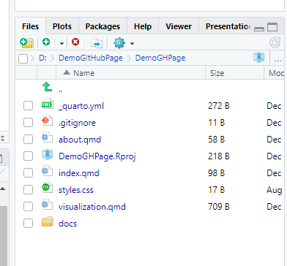

Then go to terminal and type

copy NUL .nojekyll

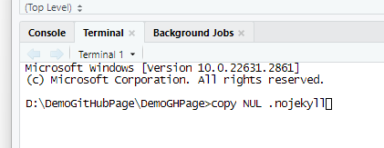

**Now the problem is that files inside the DemoGHPage so can not be recognized by GitHub, so how to deal with this?**

So I need to copy all the files and paste into DemoGitHubPage

Then stage them in Git

The Committ and Push

The you will see all your files inside your GitHub

Then edit the setting at GH Pages choose “main”, choose “/docs”, click “save”

And wait for a minute a so for it to render, until you receive this

